**ASSESSING AIR PURITY: A STEP-BY-STEP GUIDE TO AIR QUALITY INDEX ANALYSIS**

**RESEARCH QUESTIONS**

What are the primary pollutants contributing to poor air quality in Delhi ?

How are they impacting the environment ?

How are the concentrations of these pollutants over the time?

What Solutions can be proposed to go against this pollution in Delhi ?

**BREAKDOWN OF THE VARIOUS STEPS**

1. **Load the Dataset**: Load your CSV file using Pandas and parse the date column for easier time series manipulation.
2. **Data Preparation and pre-processing on the gathered information**: Check for missing values in the dataset to understand the data quality.
3. **Descriptive Statistics and required equations**:Generate summary statistics for key pollutants to get an overview of the data distribution and central tendencies.
4. **Visualizations**: Use Matplotlib to visualize the trends of key pollutants over time.

**CODE_SNIPPET**

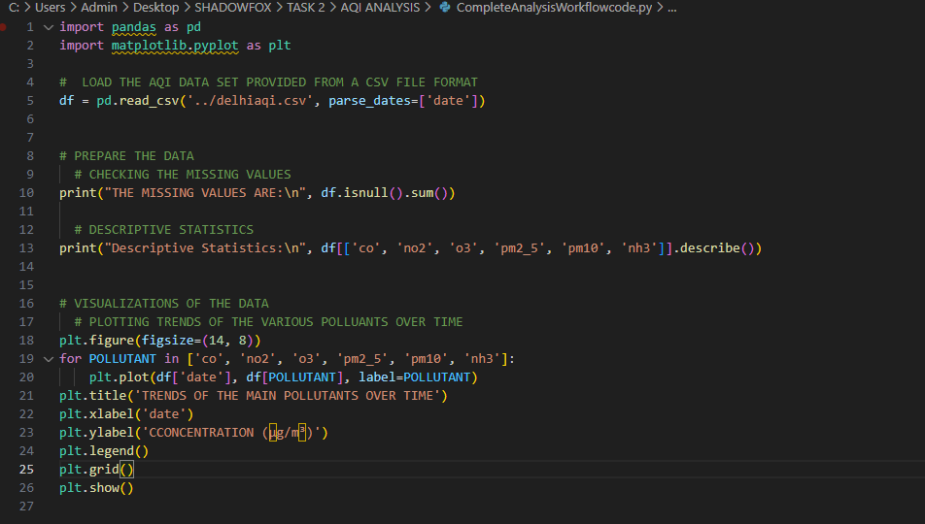

**OUTPUT**

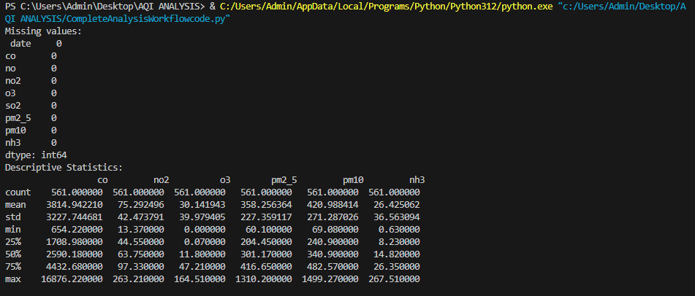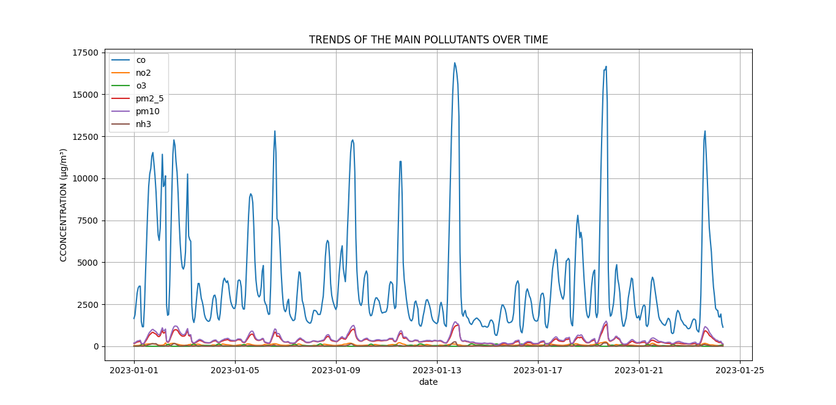

**ANALYSIS AND INTERPRETATION**

1. **Missing Values**

The dataset is complete because there was no missing value and no imputation was needed.

**2. Descriptive Statistics**

* CO (Carbon Monoxide):

- Mean: 3814.94 µg/m³

- The maximum value (16876.22 µg/m³) is significantly higher than the mean and the 75th percentile, indicating potential spikes in CO levels, likely due to localized pollution events or traffic congestion.

* NO2 (Nitrogen Dioxide):

- Mean: 75.29 µg/m³

- The maximum concentration (263.21 µg/m³) shows potential issues related to vehicle emissions or industrial activity.

* O3 (Ozone):

- Mean: 30.14 µg/m³

- The low average and high variability suggest that ozone pollution is not consistently high, but certain peaks are likely driven by photochemical reactions (e.g., due to sunlight).

* PM2.5 (Particulate Matter of diameter 2.5):

- Mean: 358.26 µg/m³

- The maximum value (1310.20 µg/m³) is dangerously high, with the mean and 75th percentile also indicating consistently high levels of fine particulate matter. This poses a severe health risk.

* PM10 (Particulate Matter of diameter 10 :

- Mean: 420.99 µg/m³

- Similar to PM2.5, the levels of PM10 are concerning, with peaks reaching 1499.27 µg/m³. This suggests heavy pollution from dust, construction activities, and other particulate sources.

* NH3 (Ammonia):

- Mean: 26.43 µg/m³

- Ammonia levels seem relatively low compared to other pollutants, though there are occasional spikes (max of 267.51 µg/m³), likely from agricultural activities or waste management.

**3. Trends in the Plot**

- The chart shows that **CO** dominates the pollutant concentration. It has frequent peaks, indicating pollution spikes, possibly from traffic, industrial activities, or burning of fuels.

- **PM2.5** and **PM10** exhibit similar trends, reflecting particulate pollution from construction, dust, and other sources. The elevated levels of particulate matter over time are concerning.

- Other pollutants like **NO2**, **O3**, and **NH3** remain relatively lower in concentration compared to CO and particulate matter, but they still show periodic increases.

**CONCLUSION**

* **Severe Air Quality Issues:** Both **PM2.5** and **PM10** are significantly above recommended levels, posing a severe public health risk. Long-term exposure to these pollutants is linked to respiratory and cardiovascular diseases, as well as premature mortality.

* **Carbon Monoxide Spikes**: The spikes in **CO** concentration may suggest periods of heavy traffic or localized sources of pollution, such as industrial emissions or biomass burning. These peaks should be closely monitored to mitigate short-term exposure.
* **Nitrogen Dioxide and Ozone:** While **NO2** levels are concerning, especially in peak times, **Ozone** remains relatively low on average but shows peaks likely driven by photochemical smog formation, a common issue in urban areas with heavy sunlight exposure.
* **Ammonia Concentration**: **NH3** levels are low on average, but peaks could indicate the presence of agricultural or waste management activities. High levels of ammonia can contribute to secondary particulate formation (ammonium nitrate, ammonium sulfate), which further degrades air quality.

**Recommendations**:

**1.** **Immediate Action on Particulate Matter (PM2.5 and PM10):**

- Implement stricter regulations on construction, road dust, and industrial emissions to reduce particulate matter.

- Encourage the use of dust suppression techniques and improve waste management to minimize PM levels.

**2.** **Monitoring and Regulation of Traffic Emissions**:

- Given the high levels of **CO** and **NO2**, traffic emissions need tighter regulation. Promote the use of cleaner vehicles (e.g., electric or hybrid vehicles), implement congestion zones, and strengthen public transportation networks.

- Increase the number of monitoring stations across the city to better track and respond **to CO** and **NO2** spikes.

**3.** **Public Health Warnings and Awareness:**

- Publicize air quality data more widely, particularly during high pollution periods. Issue health warnings to vulnerable groups (children, elderly, and those with respiratory conditions) when air quality is poor.

- Encourage the use of air purifiers and masks during periods of high pollution.

**4.** **Long-Term Strategies**:

- Develop green belts and increase tree coverage to naturally reduce air pollution.

- Encourage renewable energy adoption to reduce the reliance on fossil fuels, which are major sources of pollutants like **CO**, **NO2**, and **PM**.

.